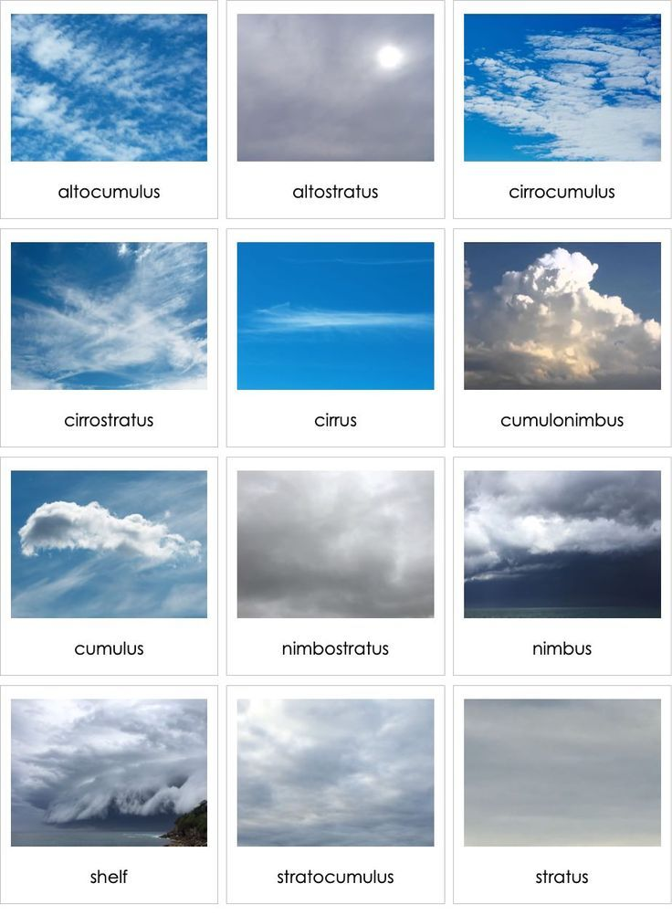
TYPES OF CLOUDS IMAGES

